**CMPE536 Metaheuristics**

**Fall 2020-2021**

**Assignment I**

**In this assignment you are assigned randomly to one of the following algorithms aveilable in Table I. You have to solve at least 2 QAP Problem given in Problem Description section.**

|  |
| --- |
| **Algorithms** |
| 1. **Local Serach** |
| 1. **Iterated Local Serach** |
| 1. **Guided Local Serach** |
| 1. **Variable Neighborhood Search** |
| 1. **Tabu Serach** |
| 1. **Simulated Annealing** |

**Table I**

**Problem Description**

**Goal:**

In the Quadratic Assignment Problem (QAP), n units (usually departments, machines, or electronic components) must be assigned to n locations given the distance between the locations and the flow between the units. The goal is to find the assignment that minimizes the sum of the products of distance traveled and flow between the units.

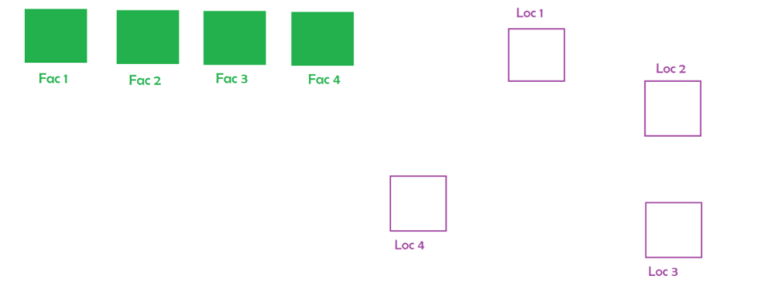In the QAP n units(facilities, departments, machines, or electronic components) must be assigned to n locations give the matrixes of flow.

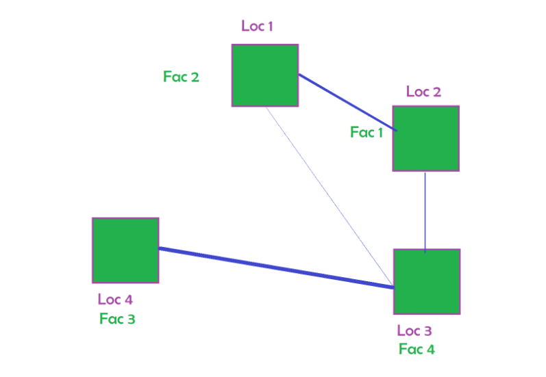

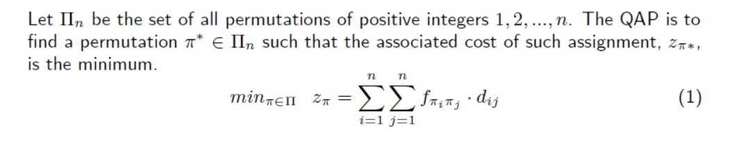

**Data:**

The format of the data is as follows:

* Number of points
* Matrix A (d): distance between each location
* Matrix B (f) : flow between each facility

**Problems:**

**Tai12a.dat**

**Tai12b.dat**

**Tai15a.dat**

**Tai17a.dat**

**Tai100a.dat**

**Optimal Solutions:**

[**https://coral.ise.lehigh.edu/data-sets/qaplib/qaplib-problem-instances-and-solutions/#Ta**](https://coral.ise.lehigh.edu/data-sets/qaplib/qaplib-problem-instances-and-solutions/#Ta)

|  |  |  |  |  |
| --- | --- | --- | --- | --- |
| # | C.Code | Grup | Std.Id | Problem |
| 1 | CMPE536 | 01 | 18500574 | **Local Serach** |
| 2 | CMPE536 | 01 | 18500772 | **Guided Local Serach** |
| 3 | CMPE536 | 01 | 19500561 | **Tabu Serach** |
| 4 | CMPE536 | 01 | 19500650 | **Variable Neighborhood Search** |
| 5 | CMPE536 | 01 | 20500070 | **Iterated Local Serach** |
| 6 | CMPE536 | 01 | 20500231 | **Tabu Serach** |
| 7 | CMPE536 | 01 | 20510428 | **Iterated Local Serach** |
| 8 | CMPE536 | 01 | 20510466 | **Variable Neighborhood Search** |
| 9 | CMPE536 | 01 | 20600059 | **Simulated Annealing** |
| 10 | CMPE536 | 01 | 20610116 | **Variable Neighborhood Search** |
| 11 | CMPE536 | 01 | 20610118 | **Simulated Annealing** |